Name: Bailey Garner

Student ID: 1208566381  
Date: 10-5-18

**Instructions:** Congratulations, you made it to the end of the course! You should have at least six pages of your site completed by the time you submit this. Use the following to have a written discussion about your experience in the course and the final project.

**Before submitting this document and all of your project files, make sure you meet all of these requirements:**

* You have complete the “Final Submission and Discussion” worksheet.
* You have zipped up or compressed your final project folder (including all of your HTML, CSS, images, videos, etc.)
* You have one (1) home page and six (6) (but no more than eight (8)) content pages.
* **Each page** must contain appropriate text and images that provide information and value to the target audience.
* **Each page** must contain appropriate page titles.
* You must make use of the HTML5 tags (HEADER, NAV, MAIN, and FOOTER)
* You must include one (1) table utilizing data effectively (not per page).
* You must include one (1) video (you are not required to create the video, there are many sharable videos on the Web – chose one that is relevant to your project). The idea behind this is to use the <video> tag, so embedding all YouTube iFrames does not qualify (you can however just do 1 <video> tag and the rest YouTube embed iFrames – but make it easy for me to find the video using the <video> tag).
* You must include one (1) e-mail link.
* You must include one (1) external link (link to another page.
* **Each page** must contain appropriate description meta tags.
* You must include one (1) form (four (4) fields minimum. You do not need to setup the server side processing (since we really didn’t go over it in class). You can use **action=”#”**. Keep in mind, the form will not submit correctly when you hit the submit button. Additionally, you can use **action="http://webdevbasics.net/scripts/demo.php"** and it will accept any form fields you pass to it (keep in mind it won’t look right since it uses the pacific styling).
  + Form must reside on project site (linking to an external form is not allowed)
* You must include one (1) external style sheet (CSS) which contains a minimum of six (6) styles
* Do NOT screenshot the code because we can’t run the code. Save the file to yourasurite – Project – Submission 7 – Publish and Discuss Project.docx file and yourasurite – Project – Submission 7– Publish and Discuss Project.pdf file. Submit both files to Blackboard.
* Zip your FinalProject code folder and named it yourasurite-FinalProject.zip. Submit that zipped file to Blackboard too. Make sure you change “yourasurite” to yours asurite.

**Discussion Questions**

1. **Now that you are finished with your project, your original concept of your project might have changed a lot. Discuss in detail the differences between your initial project design and your final product. Why did you make these changes (if you had any)?**  
     
   I didn’t change a whole lot from my original design. One of the largest changes that I made was that I decided not to use JavaScript in my submissions page because it would’ve added too much complexity that I didn’t quite have time to add. Originally I wanted to use the jQuery library to dynamically build the submissions page for multiple types of submissions, but instead I decided to just keep it to review submissions.
2. **Describe in detail why you chose the design layout you did. Are you happy with the outcome? Did you run into any issues with your design while developing your site? What did you do to overcome those issues? Would you do anything differently the next time you designed a website?**   
     
   I chose to use a fairly basic design layout that boxes information together. I like the boxed layout quite a lot because I think that it draws the viewers eyes to information that goes together quite well. I decided to go with a mostly monochromatic theme for my website because I think that the blue looks really nice and having different shades of a color flows much better to me than big contrasts in color. I think this makes the site very readable.

One issue that I ran into while designing my site was using floats for layout. I often had trouble getting images to stay within the correct overflows and layouts. To overcome these issues I did a lot of googling about how float works and how to get things to properly layout, as well as lots of trial and error.

The next time that I design a website I would likely try to design a mobile version first and then move to designing for desktop, as I think that transition will work much better.

1. **You likely encountered challenges while working on your final project. In detail, describe the challenges you encountered and what you did to overcome them.**   
     
   Like I discussed in the previous questions, one of my biggest challenges was layout with floats. I had to learn how to use the clear property to get layouts to work correctly. I also often ran into unknowns about when I should use “margin” and when I should use “padding”, so I did a bit of research into the major differences and how I used them on the site.

My homepage with the three column layout was the most difficult to layout. I really wanted three different sets of information on this page so laying it out in three different sections made the most sense, but it took some googling to figure out how to create columns since I’m used to using Bootstrap’s column system. I found that getting all of the CSS styles to play nice with each other was the most challenging part, and making sure that I was only styling what I intended to rather than a site wide style.

1. **Describe several concepts that you learned during this course that you found interesting and useful. Where there any concepts that you wish more time was spent on? Is there anything you would have like to incorporate into your final project that wasn’t covered during this course?**  
     
   I wish more time would have been spent on layout as this was one of the things that I think could have been useful. I also would have liked to see some JavaScript covered during this course as I think that using JavaScript on a website really is what takes it to the next level as far as usefulness and modern pages. Being able to dynamically change content on the page would’ve been cool to learn.
2. **OPTIONAL (NOT REQUIRED FOR THE CLASS OR FACTORED INTO YOUR GRADE): If you took advantage of the “Getting Online” video in the Week 6 / Chapter 12 folder and setup a domain and hosting, what were your thoughts on the process? Did you run into any issues? What domain did you pick? Did you upload your files? You may have already answered this in the update #2, but some students wait until the end to complete this.**  
     
   I did end up putting my site online, as I answered in the previous update. My site can be found at: <https://bwgarne1.github.io/>
3. **While trying to be as objective and unbiased as possible, please go through and critique your own site using the attached rubric. In the student critique column, indicate which score you should receive for each category (outstanding, average, or needs improvement) and write a short (1 or two sentence max) justification of that score.**

**Student Critique**

|  |  |  |  |  |
| --- | --- | --- | --- | --- |
|  | **Outstanding** | **Average** | **Needs Improvement** | **Student Critique** |
| **EXAMPLE** | You did everything! | You did a few things. | You did nothing… | Outstanding – I believe I did everything correctly because of x, y, and z. |
| **Discussion Questions: Answers** | Clearly and completely answered the questions. | Answers to questions could have been more complete or more clear. | Answers were missing. | Outstanding – I believe that I’ve fully answered all of the questions. |
| **Discussion Questions: Mechanics** | Organized, neat in appearance, easy to read and understand. | Some improvement is needed in the organization or appearance and/or the document is not easy to read or understand. | Answers were missing. | Outstanding – I think that my answers are clear and the ideas are logically grouped in paragraphs when necessary. |
| **Visual Appeal** | Use of color, contrast, text, graphics is appealing to target audience | Appealing to target audience in all but one area. | Not appealing to target audience in more than one area | Outstanding – The monochromatic color scheme with different shades of blue is pleasing to the eye, the images are all nicely formatted to be the same size and have nice shadowing to make them pop to the viewer. |
| **Navigation** | Easy to use, consistent | Inconsistent or difficult to use | Missing | Outstanding – The navigation is consistent on all pages and contains links to all pages. Tips when attending a performance are nicely grouped in their own dropdown navigation. |
| **Accessibility** | W3C Guidelines followed | Two or fewer instances where W3C guidelines are not followed | Three or more instances where W3C guidelines are not followed | Oustanding – Guidelines are followed, site is usable |
| **Page Titles/ Logo Area** | Descriptive and include the site/company name | -- | Missing or does not include the site/company name | Outstanding – Logo appears on all pages with the sites name, each page is labelled with a descriptive heading |
| **Table** | Present and correct syntax | -- | Missing or incorrect syntax | Oustanding – Multiple tables throughout website, 4 total tables with correct syntax present |
| **Graphics** | Present and correct syntax | -- | Missing or incorrect syntax | Oustanding – Graphics used on nearly every page, pages use graphics well to support the text information, graphics have all necessary fields, graphics are sized well for the page |
| **Video** | Present and correct syntax | -- | Missing or incorrect syntax | Outstanding – Video is present and playable and ties into the content of the page. |
| **E-mail Link** | Present and correct syntax | -- | Missing or incorrect syntax | Outstanding – Present on all pages in the footer area, email was created for this class, properly opens up an email client |
| **Outside Link** | Present and correct syntax | -- | Missing or incorrect syntax | Outstanding – MULTIPLE outside links present, many pages have links to outside pages for ticket purchasing |
| **Meta tag** | Correct syntax (description meta tags), excellent selection of keywords and meaningful description | Correct syntax (description meta tags), adequate selection of keywords and description | Missing or incorrect syntax | Oustanding – Same description appears on all pages but each page is tweaked to ensure a good selection of keywords describing that page. |
| **Form Coding** | Contains 4 or more form fields, correct syntax, and meaningful form element names | Does not contain the required 4 form fields, incorrect syntax, or names of fields don’t make sense. | Missing | Oustanding – Form contains 7 relevant fields and has 4 different types of fields (text, date, textarea, email) Form elements have names that make sense. |
| **Form Processing** | Form uses # or the pacific.php script as the action. | -- | Form not configured correctly. | Oustanding – Form is processed with action “#” as required. |
| **XHTML Validation** | Required number of pages pass | Less than the required number of pages pass | No pages pass | Oustanding – All 8 HTML pages pass w3c validation |
| **CSS Validation** | External CSS file is present and passes validation | External CSS file is present but does not pass validation | External CSS file is not present or does not pass validation | Oustanding – External CSS file exists with many more styles than required and passes validation |

**Web page browser view screenshot of Home Page**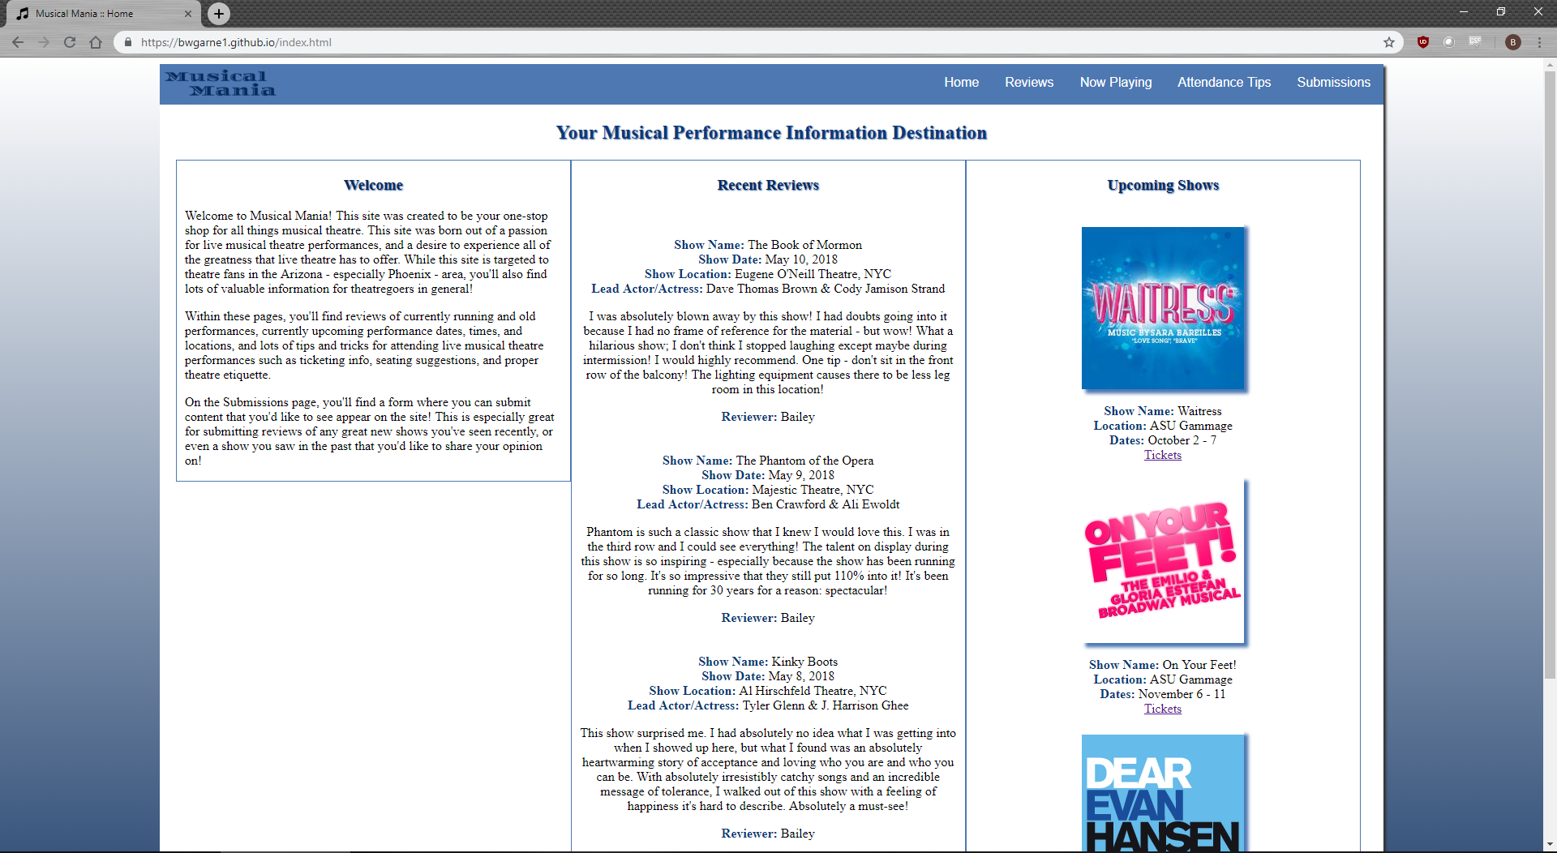



**Web page browser view screenshot of Page #1**

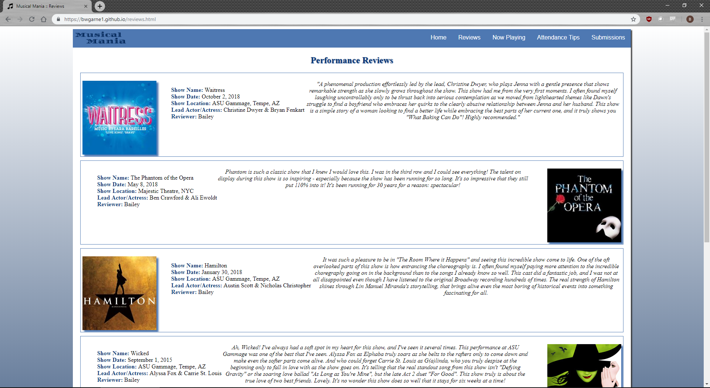

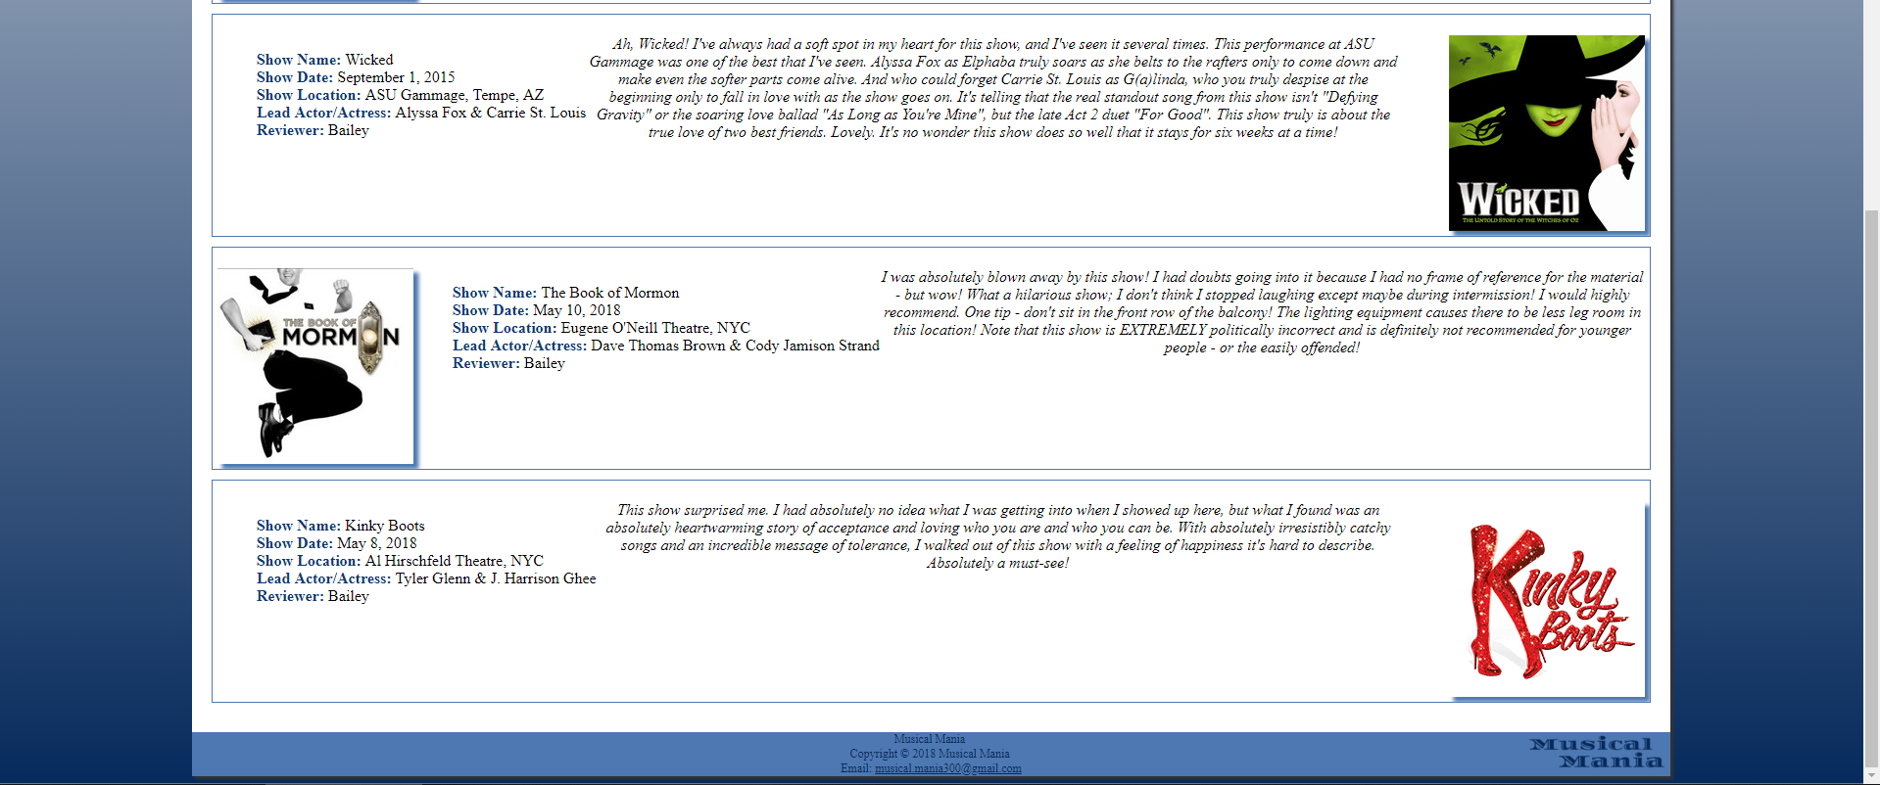

**Web page browser view screenshot of Page #2**

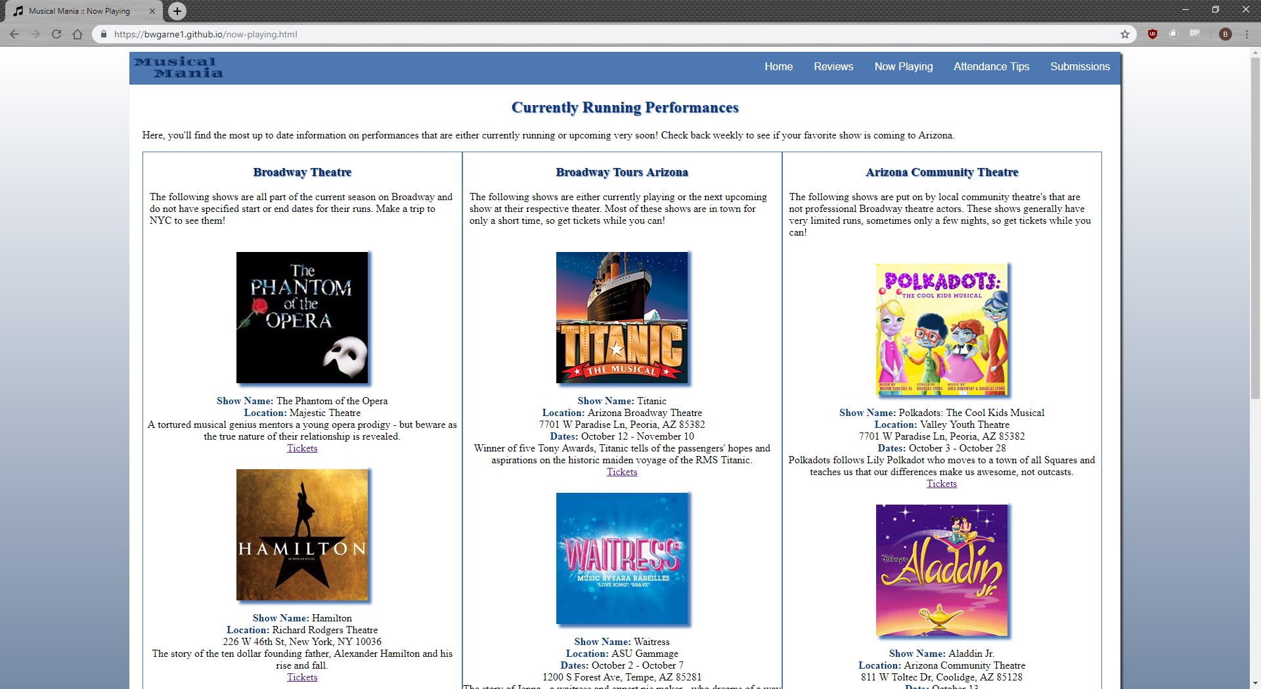

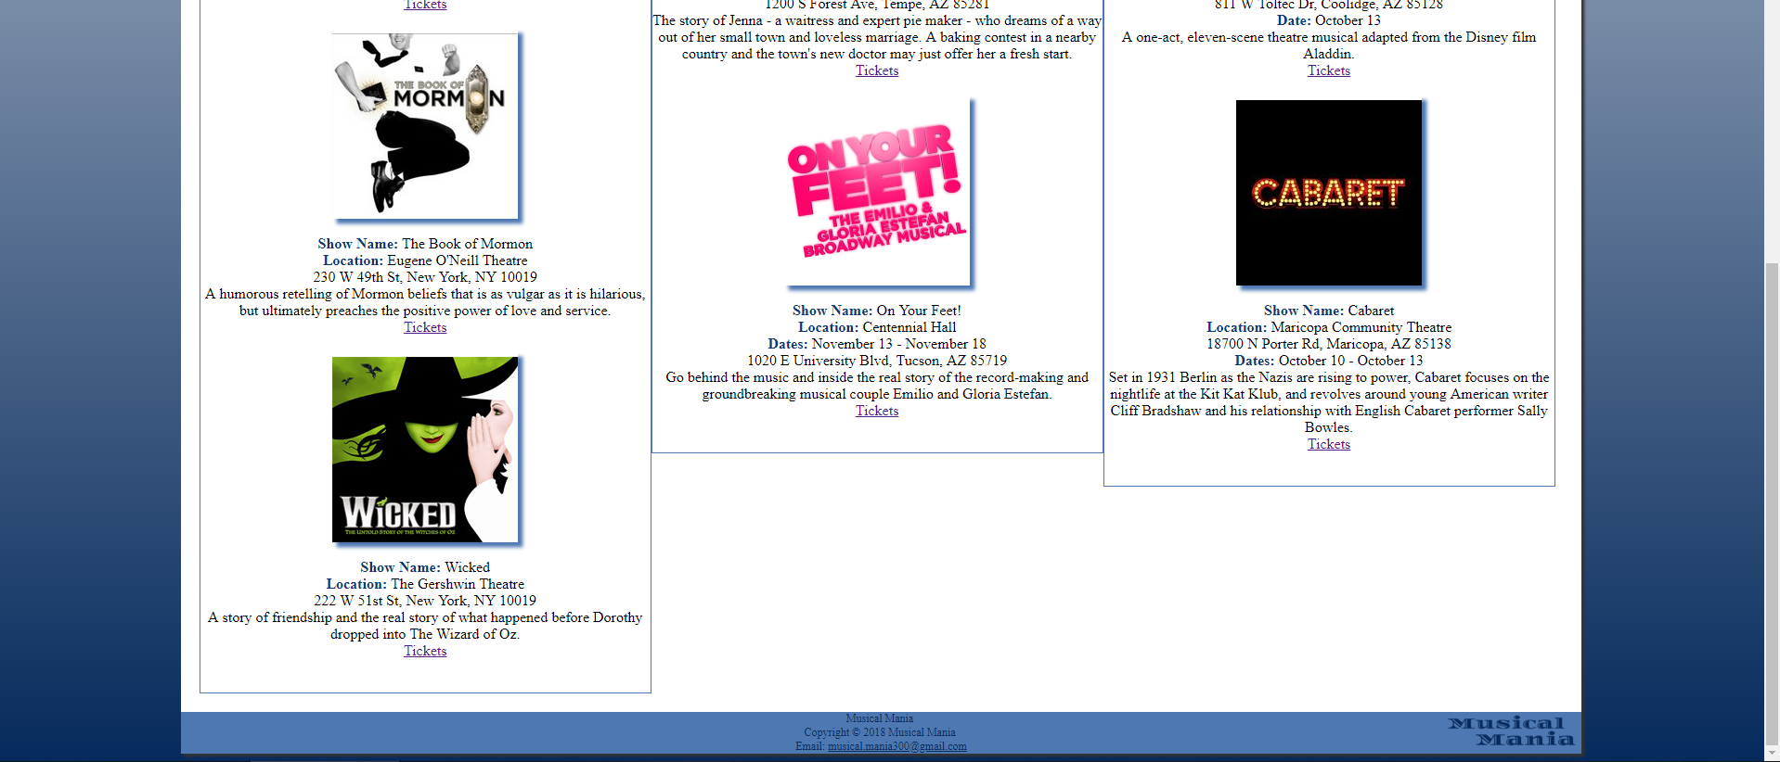

**Web page browser view screenshot of Page #3**

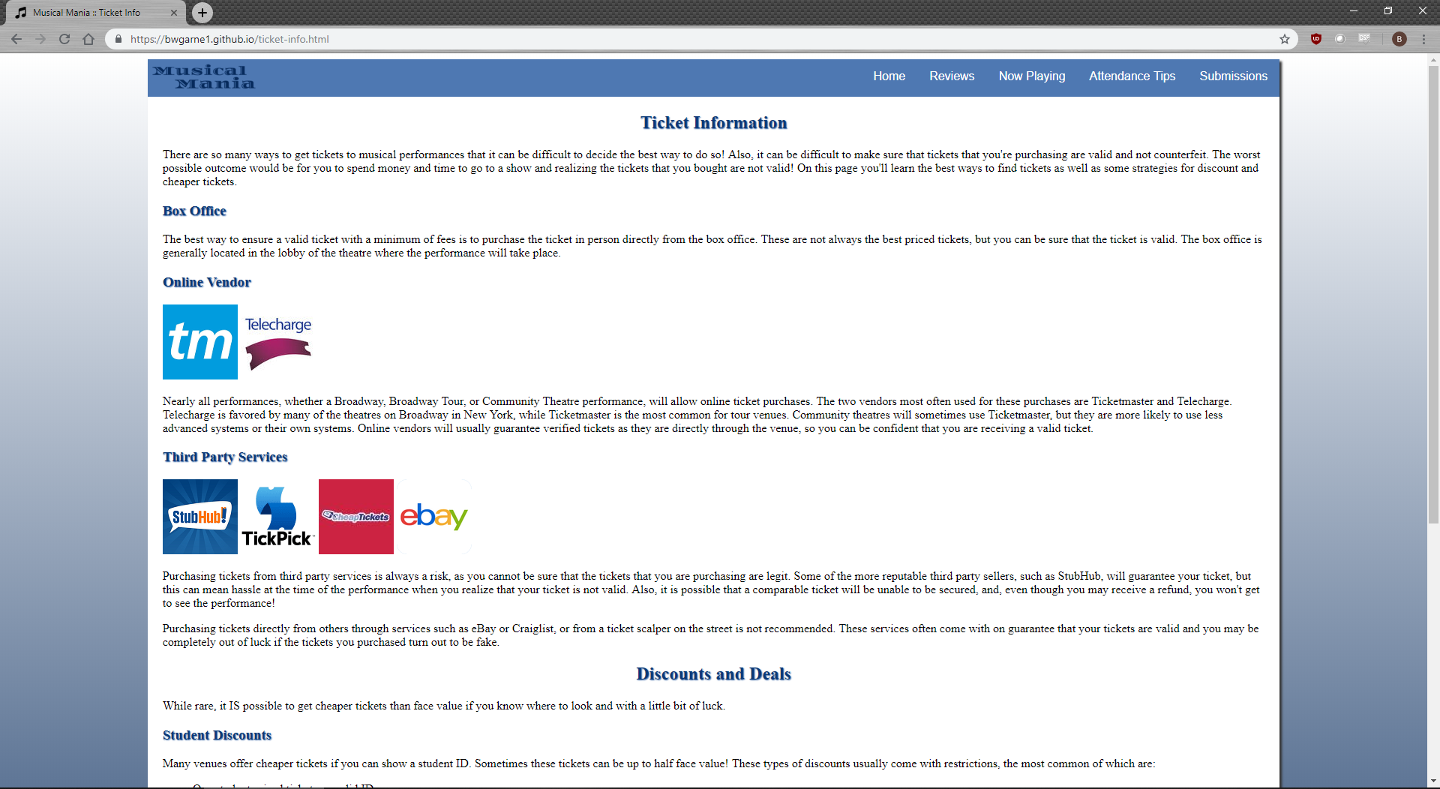

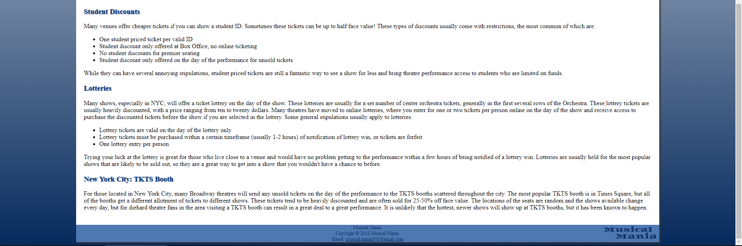

**Web page browser view screenshot of Page #4**

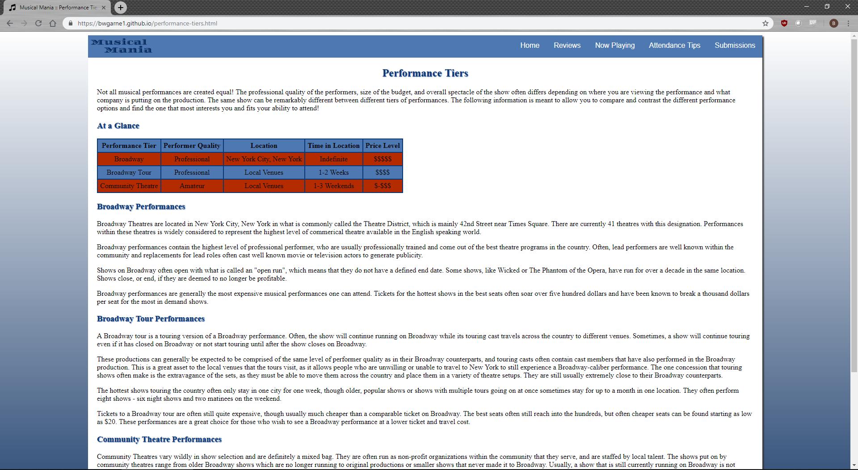

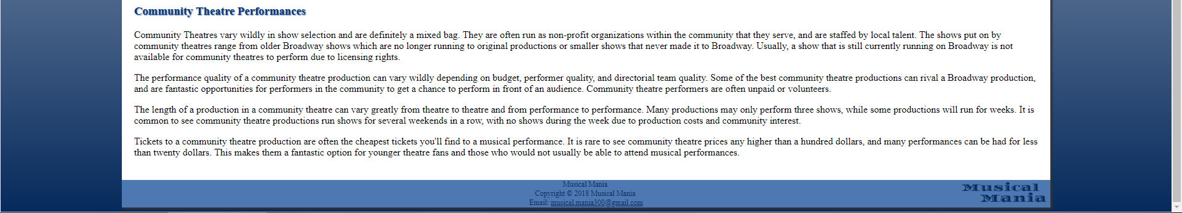

**Web page browser view screenshot of Page #5**

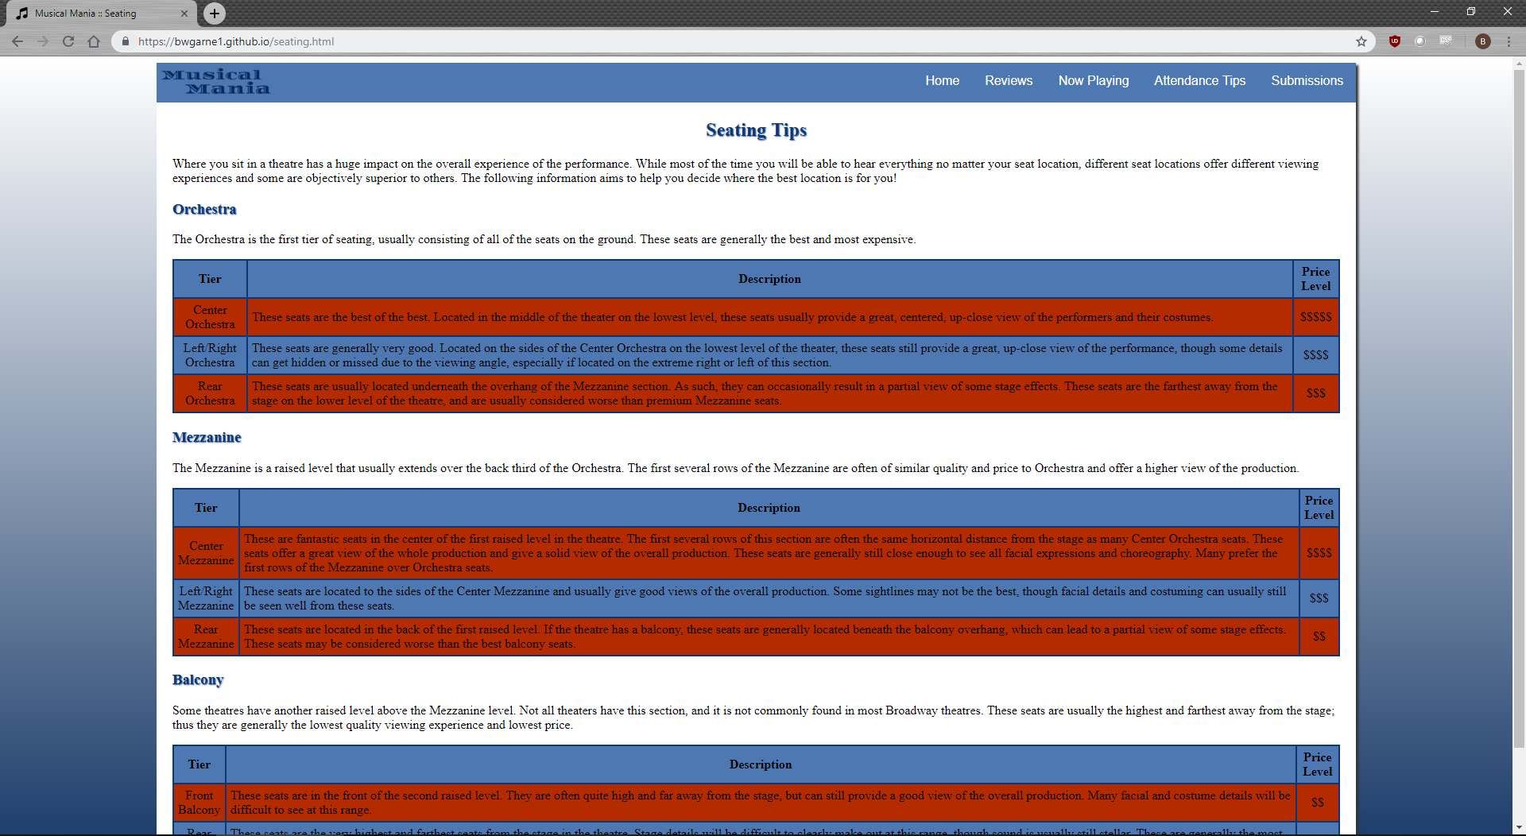

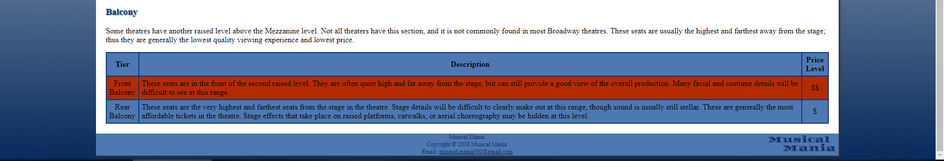

**Web page browser view screenshot of Page #6**

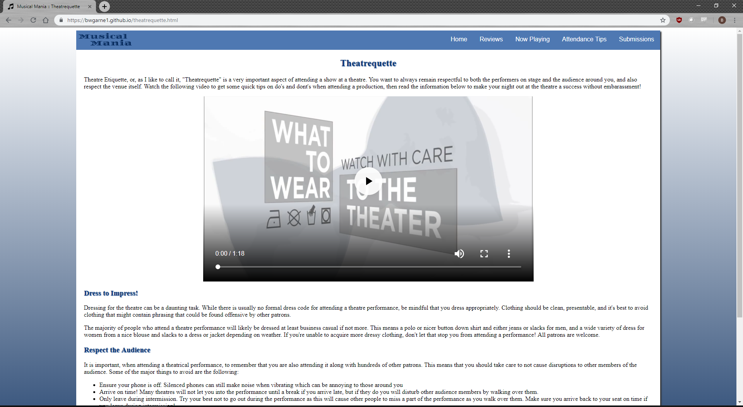

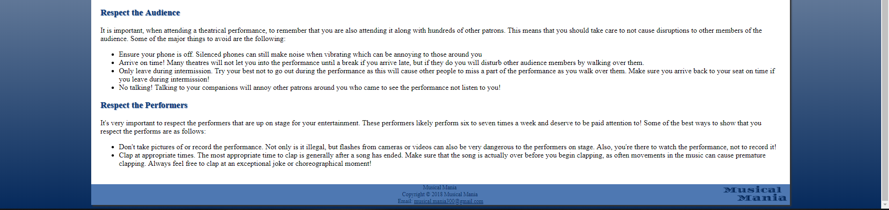

**Web page browser view screenshot of location you used a table**

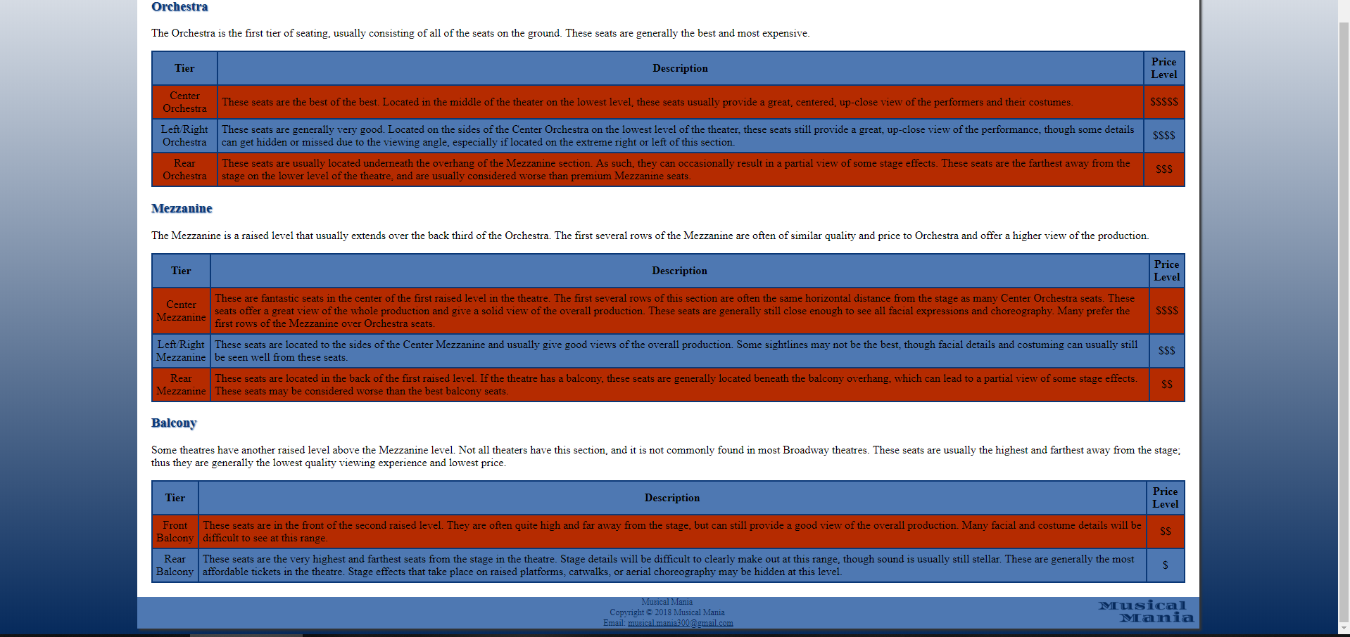

**Web page browser view screenshot of where you used the <video> tag**

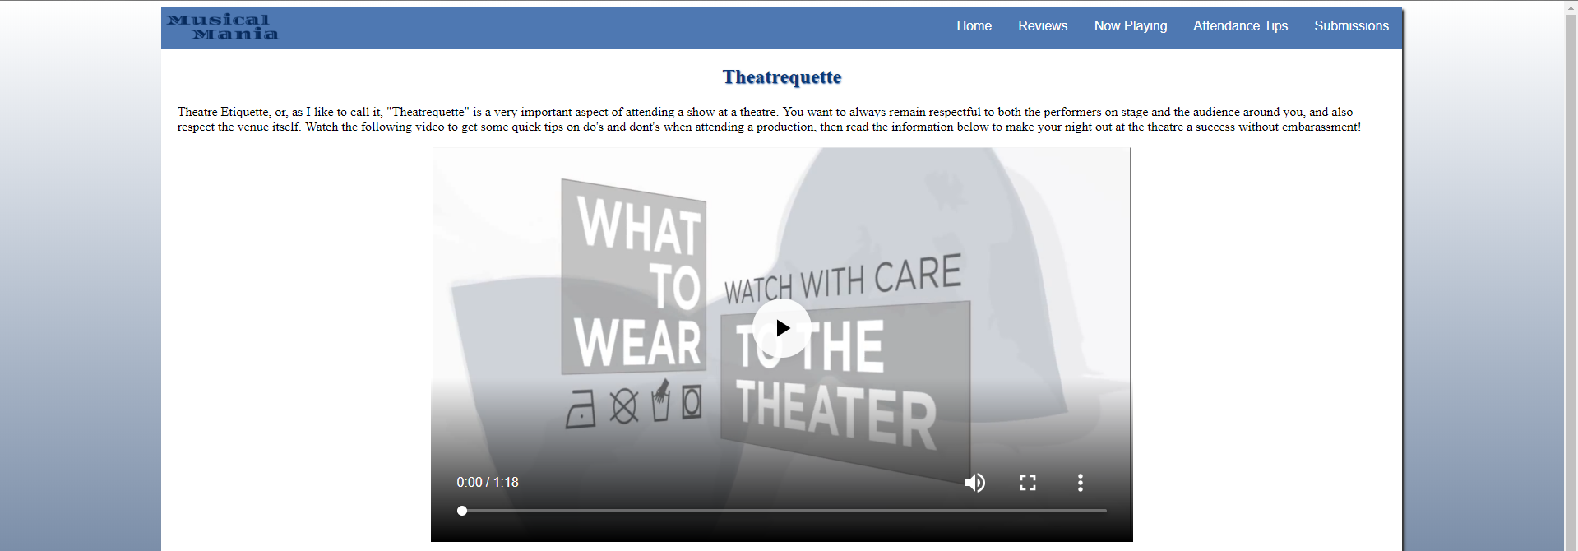

**Web page browser view screenshot of where you used an e-mail link**



**Web page browser view screenshot of where you used an external link**

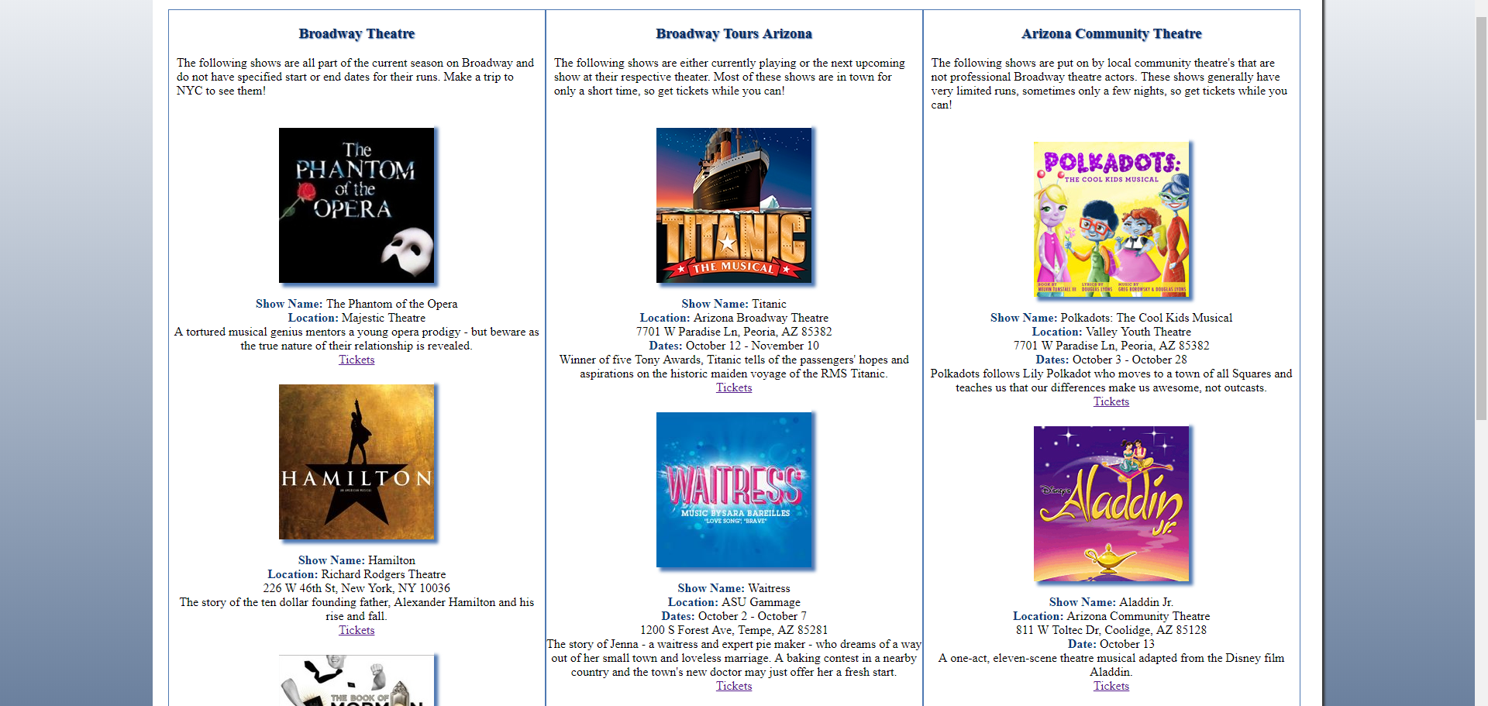

**Web page browser view screenshot of your form**

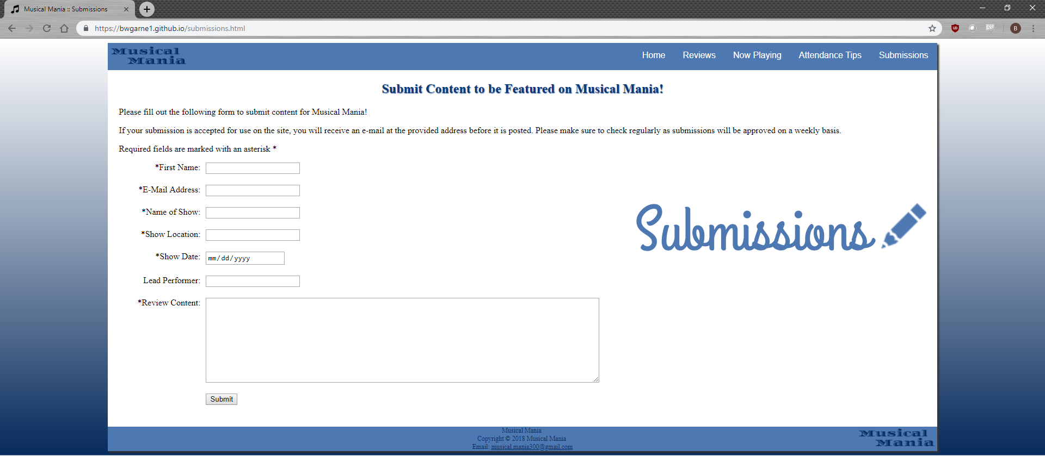

**READY TO SUBMIT? MAKE SURE YOU ZIP/COMPRESS YOUR WHOLE PROJECT FOLDER AND ATTACH BOTH THIS DOCUMENT AND YOUR PROJECT FOLDER.**